­­Multiple-choice section – choose the correct answer

Question 1 [8.1]

Which of the following surveys could be carried out by observation?

A The height, in cm, of each person in the train carriage

B The number of students in each class who are in full school uniform

C The number of second−hand cars in the car park at your school

D The level of support for a proposed change to the school uniform

Question 2 [8.2]

3, 1, 1, 2, 6, 4, 0, 7

The mean and median, respectively, of the set of eight data is:

A 4, 4 B 4, 2.5 C 3, 2.5 D 3, 4

Question 3 [8.3]

The class centre for a class interval of 25−29 is:

A 26.5 B 26.75 C 27 D 27.5

Question 4 [8.5]

The probability of choosing, by random selection, a red ball from a bag containing 3 red balls, 2 white balls and 4 brown balls is:

A  B  C  D 

Question 5 [8.5]

A die was rolled 30 times. The table shows the frequency of each number rolled.

|  |  |  |  |  |  |  |
| --- | --- | --- | --- | --- | --- | --- |
| Face | 1 | 2 | 3 | 4 | 5 | 6 |
| Frequency | 7 | 3 | 4 | 5 | 6 | 5 |

The relative frequency of a 4 was:

A  B  C  D 5

Question 6 [8.5]

A bowl contains 30 identical balls numbered 1 to 30. A ball is drawn at random from the bowl. The probability that the number on the ball is a multiple of 4 and a multiple of 6 is:

A  B  C  D 

Question 7 [8.7]

Sheldon has cereal for breakfast every day. Each day he randomly selects from the five different cereals on his shelf. The probability that Sheldon has *Korny Kobs*, one of the cereals on the shelf, two days in a row is:

A  B  C  D 

Question 8 [8.7]

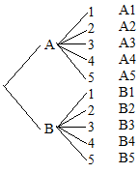

For the tree diagram above the probability of B with an even number is:

A  B  C  D 

Multiple-choice results: ___ / 8

Short answer section

Question 9 3 marks [8.1] [8.5]

categorical data certain chance continuous data discrete data

impossible random sample skewed symmetrical

Complete the following using words from the list above.

(a) An event for which the probability is 0 is said to be ____________________ .

(b) The number of goals scored by each team in one round of a netball competition is an example of ____________________.

(c) If a statistical graph is not skewed it is said to be ____________________.

Question 10 4 marks [8.5]

Write words and phrases associated with probabilities of:

:

:

:

:

Question 11 4 marks [8.2]

Find the mean, median and range of the tabulated data set below.

|  |  |  |
| --- | --- | --- |
| *x* | *f* | *x* × *f* |
| 30  31  32  33  34 | 15  16  6  3  1 |  |
|  |  |  |

Question 12 6 marks [8.3]

The following frequency table shows the distance thrown, in metres, by the students in the javelin competition at the Annual Athletics Carnival.

|  |  |  |  |
| --- | --- | --- | --- |
| Distance (m) | Frequency (*f*) | Midpoint (*x*) | *xf* |
| 0−<10 | 3 |  |  |
| 10−<20 | 15 |  |  |
| 20−<30 | 20 |  |  |
| 30−<40 | 11 |  |  |
| 40−<50 | 2 |  |  |
|  | Σ*f* = |  | Σ*xf* = |

(a) Calculate an estimate for the mean distance thrown by the competitors. (Fill in the blank columns above to help you find this estimate.)

(b) Construct a histogram on the axes provided.

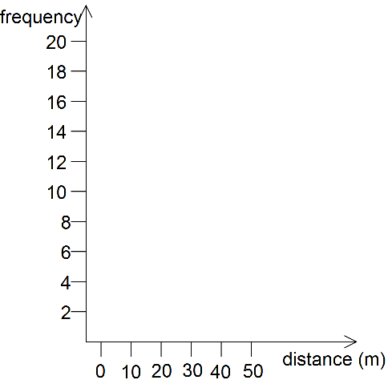

(c) Looking at your histogram, would you say that the data is symmetrical, positively skewed or negatively skewed?

Question 13 2 marks [8.5]

Nikki and Steven like playing tennis. Nikki has won 12 of the last 20 games played.

(a) Estimate the probability that the next game is won by Steven. Write your answer as a percentage.

(b) How many of the next eight games will Nikki expect to win?

Question 14 3 marks [8.5]

A box of coloured lollies contains 12 red, 5 orange, 1 pink and 3 brown.

(a) If a lolly is chosen at random, what is the probability it is neither red nor pink?

(b) If 8 lollies are chosen at random how many would you expect to be pink or brown?

Question 15 7 marks [8.6]

A bowl contains 20 small identical tiles each marked with a different number from 1 to 20. The following sets have been defined.

*A* = ‘even numbers’ *B* = ‘odd numbers’ *C* = ‘multiples of 4’ *D* = ‘2, 3, 5, 7, 11, 13, 17, 19’

(a) State whether or not each of the following pairs of sets are mutually exclusive.

(i) *A* and *B*

(ii) *A* and *C*

(iii) *A* and *D*

(b) If one tile is drawn at random, what is the probability that it will belong to group:

(i) *B* and *D*

(ii) *C* or *D*

(iii) *A* and *B*

(iv) *B* only?

Question 16 8 marks [8.7]

A bowl contains three red marbles, two yellow marbles and one blue marble. Two marbles are drawn from the bowl without replacement.

(a) Complete the array to show the sample space.

|  |  |  |  |  |  |  |  |  |  |  |  |  |  |  |  |  |  |  |  |  |  |  |  |  |  |  |  |  |  |  |  |  |  |  |  |  |  |  |  |  |  |  |  |  |  |  |  |  |  |  |
| --- | --- | --- | --- | --- | --- | --- | --- | --- | --- | --- | --- | --- | --- | --- | --- | --- | --- | --- | --- | --- | --- | --- | --- | --- | --- | --- | --- | --- | --- | --- | --- | --- | --- | --- | --- | --- | --- | --- | --- | --- | --- | --- | --- | --- | --- | --- | --- | --- | --- | --- |
| |  |  |  |  |  |  |  | | --- | --- | --- | --- | --- | --- | --- | |  | R1 | R2 | R3 | Y1 | Y2 | B | | R1 |  |  |  |  |  |  | | R2 |  |  |  |  |  |  | | R3 |  |  |  |  |  |  | | Y1 |  |  |  |  |  |  | | Y2 |  |  |  |  |  |  | | B |  |  |  |  |  |  | | Use the sample space to find the probability that:  (b) both marbles are red  (c) both marbles are the same colour  (d) neither marble is yellow  (e) one marble is blue and the other is yellow. |

Short answer results: ___ / 37

Extended answer section

Question 17 14 marks [8.4]

The following lists are of heights, in cm, of 30 Year 9 students from each of NSW and Victoria recorded in a particular year.

NSW students:

174 164 150 159 177 164 163 156 158 177 143 170

160 162 179 152 157 158 165 168 177 167 155 174

165 187 184 161 170 180

Victoria students:

176 164 163 146 177 167 169 180 160 170 180 177

162 165 163 169 175 167 165 170 160 183 160 170

168 155 180 171 172 183

(a) Find the mean height of the students for each of NSW and Victoria, correct to 1 decimal place.

(b) Complete the back-to-back stem-and-leaf plot of the data.

(c) Find the median height and range of heights of the students for each of NSW and Victoria.

(d) What conclusions can you draw from the stem plot regarding the height of Year 9 students from NSW compared to those from Victoria?

Question 18 8 marks [8.6]

The 26 students in your class were asked the following questions:

* Do you have a prepaid mobile phone?
* Have you been on an overseas holiday in the past year?

In summary: 18 had a prepaid mobile phone, 5 had been on an overseas holiday in the past year and 6 answered ‘No’ to both of these.

(a) Complete the two-way table for the 26 people.

|  |  |  |  |
| --- | --- | --- | --- |
|  | Prepaid mobile | No prepaid mobile |  |
| Overseas holiday |  |  |  |
| No overseas holiday |  |  |  |
|  |  |  | 26 |

(b) Complete the Venn diagram from the two-way table.

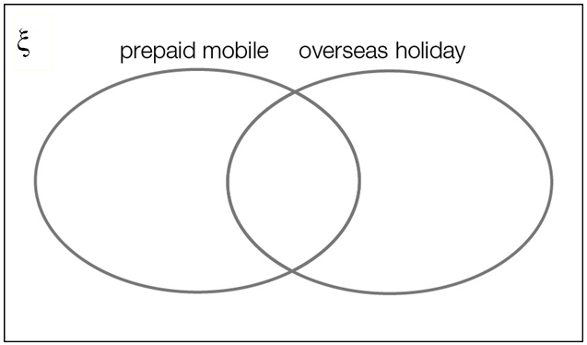

(c) If one of the members of your class was selected at random what is the probability that the person:

(i) has a prepaid mobile phone?

(ii) has a prepaid mobile phone and has been on an overseas holiday in the past year?

(iii) has not been on an overseas holiday in the past year?

(d) If you know the person chosen has been on an overseas holiday in the past year, what is the probability they have a prepaid mobile phone?

Question 19 10 marks [8.5]

Up until December 2015 Shaun Marsh had batted 30 times for Australia in Test Cricket. These are his scores:

141 81 18 44 0 0 3 0 11 3

0 148 44 0 0 32 17 32 99 73

1 19 13 11 69 0 2 2 49 182

(a) Find the mean, median and range of these scores correct to 1 decimal place.

(b) If one of Shaun’s test innings was chosen at random find the following probabilities as percentages to the nearest whole number:

(i) Pr(score from 0 to 9)

(ii) Pr(score of at least 50)

(iii) Pr(score of at least 100)

Extended answer results: ___ / 32

TOTAL test results: ___ / 77